**Disk Scheduling**

**Practice question**

1. Consider a disk with 200 tracks and the queue has random requests from different processes in the order:

55, 58, 39, 18, 90, 160, 150, 38, 184

Initially arm is at 100. Find the Average Seek length using FIFO, SSTF, SCAN and C-SCAN algorithm.

**Solution:**

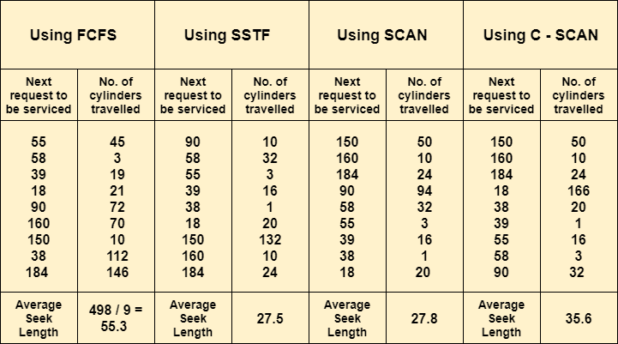

***Refer this link for details:***

[**http://examradar.com/disk-arm-scheduling-algorithm-questions-answers/**](http://examradar.com/disk-arm-scheduling-algorithm-questions-answers/)